**CHAPTER – 1**

**DATA BASE MANAGEMENT SYSTEM**

**1.1 INTRODUCTION TO DBMS**

**Definition and Overview**

A Database Management System (DBMS) is a specialized software system that facilitates the storage, retrieval, manipulation, and management of data in a structured manner. Essentially, it serves as an intermediary between users and the database, ensuring efficient data handling, integrity, security, and scalability. Unlike traditional file-based systems, DBMS offers a centralized repository where data is organized, accessed, and maintained according to predefined schemas and relational models. This structured approach enables users to perform complex queries, generate reports, and derive meaningful insights from vast datasets, thereby supporting informed decision-making and operational efficiency.

**Core Components**

Data Definition Language (DDL)

The DDL component of a DBMS facilitates the creation, modification, and deletion of database objects such as tables, indexes, views, and constraints. By defining the structure, relationships, and constraints of data elements, DDL ensures data integrity, consistency, and adherence to predefined standards and guidelines.

Data Manipulation Language (DML)

DML allows users to retrieve, insert, update, and delete data records within the database. By executing queries and transactions, DML enables dynamic data management, real-time updates, and seamless integration with application systems.

Data Query Language (DQL)

DQL provides a set of commands and operators that enable users to retrieve and manipulate data based on specific criteria, conditions, and relationships. By leveraging SQL (Structured Query Language) or other query languages, DQL facilitates complex data retrieval, aggregation, filtering, and sorting operations, thereby supporting analytical processing and reporting functionalities.

**Advantages and Benefits**

Data Integrity and Security

DBMS ensures data integrity by enforcing constraints, validations, and access controls to prevent unauthorized access, modification, or deletion of sensitive information. By implementing robust security mechanisms such as encryption, authentication, and auditing, DBMS safeguards data assets against potential threats, vulnerabilities, and breaches.

Scalability and Performance

DBMS offers scalable architectures and optimization techniques that enable efficient data storage, retrieval, and processing. By employing indexing, partitioning, caching, and query optimization strategies, DBMS enhances performance, responsiveness, and scalability, thereby accommodating growing volumes of data, users, and transactions.

Data Consistency and Reliability

DBMS ensures data consistency by maintaining atomicity, consistency, isolation, and durability (ACID) properties across transactions. By implementing transaction management, logging, and recovery mechanisms, DBMS ensures data reliability, fault tolerance, and resilience against system failures, errors, and disruptions.

**Conclusion**

In summary, Database Management Systems (DBMS) play a pivotal role in facilitating efficient data management, integrity, security, and scalability across diverse applications, industries, and domains. By offering a centralized repository, structured querying capabilities, and advanced features such as indexing, optimization, and transaction management, DBMS empowers organizations, developers, and users to harness the full potential of data assets for informed decision-making, operational excellence, and competitive advantage in today's digital landscape.

**1.2 About the Mini Project**

**TITLE: Music Player**

**Introduction**

Our Music Player Database Management System project is designed with an array of features to elevate the overall user experience. One significant aspect is its seamless integration with locally stored music files, enabling users to effortlessly manage and enjoy their offline music collection. This ensures that users have a versatile and personalized music library at their fingertips.

To prioritize security and personalized access, the system incorporates robust user authentication mechanisms, encompassing both login and sign-in features. This not only safeguards user data but also provides a foundation for personalized settings, playlists, and a comprehensive music history.

A standout feature is the support for playlist subscription. This functionality empowers users to broaden their musical horizons by subscribing to curated playlists. By doing so, users stay informed about new additions and receive tailored recommendations, enhancing their music discovery journey.

To further enhance the listening experience, our system includes a play queue management feature. Users can create, modify, and organize a dynamic playlist queue. This feature provides users with a high level of control over the order in which songs are played, contributing to a seamless and personalized listening experience that adapts to individual preferences and moods.

**CHAPTER – 2**

**ER DIAGRAM AND MAPPING**

**2.1 Introduction to ER Diagram**

**Overview**

An Entity-Relationship (ER) Diagram serves as a fundamental tool in the realm of database design and conceptual modelling, providing a visual representation of entities, relationships, attributes, and constraints within a database system. Essentially, an ER Diagram encapsulates the structural components and interrelationships among data entities, facilitating a comprehensive understanding of data requirements, logical design, and system functionalities. This introductory note aims to elucidate the core concepts, components, and applications of ER Diagrams, setting the foundation for a nuanced exploration in subsequent sections of the report.

**Core Components of ER Diagram**

**Entities**

Entities represent distinct objects or concepts within a database system, characterized by unique identifiers, attributes, and relationships with other entities. Examples of entities may include 'Student,' 'Course,' 'Employee,' 'Department,' etc., each defined by specific attributes such as 'StudentID,' 'CourseCode,' 'EmployeeID,' 'DepartmentName,' etc.

**Relationships**

Relationships delineate associations, connections, or interactions between entities within a database system, elucidating the cardinality, participation constraints, and connectivity patterns. Relationships may manifest as 'One-to-One,' 'One-to-Many,' 'Many-to-One,' or 'Many-to-Many' associations, reflecting the nature, scope, and dependencies among related entities.

**Attributes**

Attributes encapsulate descriptive properties, characteristics, or features associated with entities within a database system, providing detailed insights into data elements, data types, constraints, and validations. Attributes may be classified as 'Primary Keys,' 'Foreign Keys,' 'Composite Attributes,' or 'Derived Attributes,' each contributing to the integrity, accuracy, and usability of data within the database system.

**Applications and Significance**

**Data Modelling and Design**

ER Diagrams facilitate data modelling, conceptual design, and schema development, enabling stakeholders to visualize, analyse, and refine data structures, relationships, and dependencies within a database system. By employing ER Diagrams, designers, developers, and administrators can collaboratively devise optimal strategies, methodologies, and architectures to address specific requirements, constraints, and objectives.

**System Analysis and Development**

ER Diagrams serve as a blueprint for system analysis, software development, and implementation phases, guiding developers, testers, and stakeholders throughout the lifecycle of database projects. By delineating entities, relationships, constraints, and attributes, ER Diagrams facilitate seamless integration, migration, and evolution of database systems, ensuring scalability, reliability, and performance optimization.

**Conclusion**

In summary, Entity-Relationship (ER) Diagrams represent a pivotal tool in database design, conceptual modelling, and system development, encapsulating entities, relationships, attributes, and constraints within a visual framework. By fostering clarity, consistency, and collaboration among stakeholders, ER Diagrams enable organizations to streamline data management, enhance system functionalities, and achieve strategic objectives in the evolving landscape of information technology and digital innovation. This foundational understanding of ER Diagrams sets the stage for a comprehensive exploration, analysis, and application of advanced methodologies, best practices, and emerging trends in database design and management.

**2.2 ER Diagram**

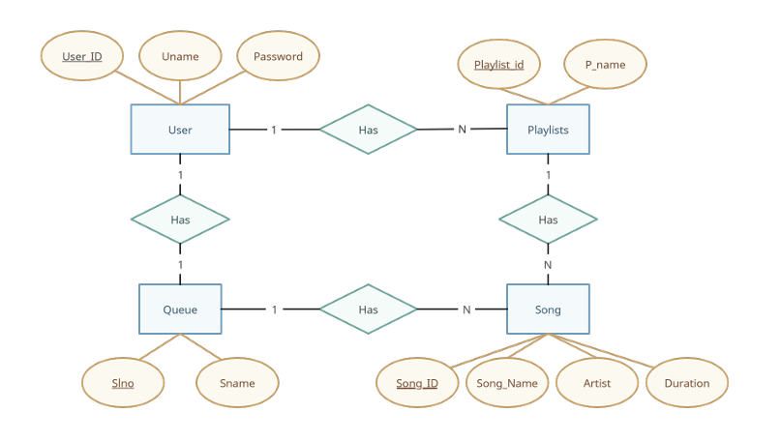

Fig 2.1: Music Player ER diagram

**ENTITY**

The basic concept that the ER model represents is an entity, which is a thing or object in the real world with an independent existence.

There are 4 entities in our project:

User

Playlists

Song

Queue

**ATTRIBUTES**

The attributes present in our project are:

User: User_id, Uname, Password

Playlist: Playlist_id, P_name

Queue: Slno, Sname

Song: Song_ID, Song_Name, Artist, Duration

**CARDINALITY RATIO**

There are 4 types of cardinality ratio:

1. 1:N
2. N:1
3. N:M
4. M:N

**ER MAPPING STEPS**

**Step 1**: Mapping of Regular Entity Types. For each regular (strong) entity type E in the ER schema, create a relation R that includes all the simple attributes of E. Include only the simple component attributes of a composite attribute. Choose one of the key attributes of E as the primary key for R. If the chosen key of E is a composite, then the set of simple attributes that form it will together form the primary key of R.

**Step 2**: Mapping of Weak Entity Types. For each weak entity type W in the ER schema with owner entity type E, create a relation R and include all simple attributes (or simple components of composite attributes) of W as attributes of R. In addition, include as foreign key attributes of R, the primary key attribute(s) of the relation(s) that correspond to the owner entity type(s); this takes care of mapping the identifying relationship type of W. The primary key of R is the combination of the primary key(s) of the owner(s) and the partial key of the weak entity type W, if any. If there is a weak entity type E2 whose owner is also a weak entity type E1, then E1 should be mapped before E2 to determine its primary key first.

**Step 3**: Mapping of Binary 1:1 Relationship Types. For each binary 1:1 relationship type R in the ER schema, identify the relations S and T that correspond to the entity types participating in R. There are three possible approaches: (1) the foreign key approach, (2) the merged relationship approach, and (3) the cross-reference or relationship relation approach. The first approach is the most useful and should be followed unless special conditions exist, as we discuss below.

1. Foreign key approach: Choose one of the relations—S, say—and include as a foreign key in S the primary key of T. It is better to choose an entity type with total participation in R in the role of S. Include all the simple attributes (or simple components of composite attributes) of the 1:1 relationship type R as attributes of S.

**Step 4**: Mapping of Binary 1:N Relationship Types. There are two possible approaches: (1) the foreign key approach and (2) the cross-reference or relationship relation approach. The first approach is generally preferred as it reduces the number of tables.

1. The foreign key approach: For each regular binary 1:N relationship type R, identify the relation S that represents the participating entity type at the N-side of the relationship type. Include as foreign key in S the primary key of the relation T that represents the other entity type participating in R; we do this because each entity instance on the N-side is related to at most one entity instance on the 1-side of the relationship type. Include any simple attributes (or simple components of composite attributes) of the 1:N relationship type as attributes of S.

**Step 5**: Mapping of Binary M:N Relationship Types. In the traditional relational model with no multivalued attributes, the only option for M:N relationships is the relationship relation (cross-reference) option. For each binary M:N relationship type R, create a new relation S to represent R. Include as foreign key attributes in S the primary keys of the relations that represent the participating entity types; their combination will form the primary key of S. Also include any simple attributes of the M:N relationship type (or simple components of composite attributes) as attributes of S. Notice that we cannot represent an M:N relationship type by a single foreign key attribute in one of the participating relations (as we did for 1:1 or 1:N relationship types) because of the M:N cardinality ratio; we must create a separate relationship relation S

**Step 6**: Mapping of Multivalued Attributes. For each multivalued attribute A, create a new relation R. This relation R will include an attribute corresponding to A, plus the primary key attribute K—as a foreign key in R—of the relation that represents the entity type or relationship type that has A as a multivalued attribute. The primary key of R is the combination of A and K. If the multivalued attribute is composite, we include its simple components.

**Step 7**: Mapping of N-ary Relationship Types. We use the relationship relation option. For each n-ary relationship type R, where n > 2, create a new relationship relation S to represent R. Include as foreign key attributes in S the primary keys of the relations that represent the participating entity types. Also include any simple attributes of the n-ary relationship type (or simple components of composite attributes) as attributes of S. The primary key of S is usually a combination of all the foreign keys that reference the relations representing the participating entity types. However, if the cardinality constraints on any of the entity types E participating in R is 1, then the primary key of S should not include the foreign key attribute that references the relation E′ corresponding to E.

**2.3 Schema Diagram**

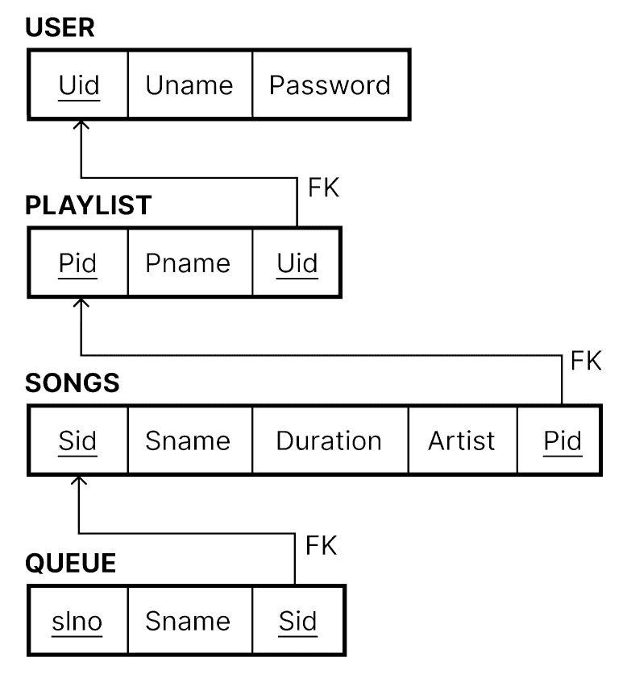

Fig 2.2: Schema diagram

**CHAPTER – 3**

**SYSTEM REQUIREMENTS**

**Front-end**: HTML and CSS

HTML and CSS are scripting languages used to enhance the user interface

**Back-end**: Python-Flask, MySQL

Flask is a python module used to deploy the application and to connect the user interface to the database. It connects with the database using flask-mysqldb module.

MySQL is a Database Management software used to create and maintain the database for the application.

**Hardware requirements**

• Windows operating system

• Minimum storage requirement

• 4GB RAM